系統易用性量表
The System Usability Scale (SUS)

這個測驗是在瞭解您在面對一個軟體時，對其易用性的感受與評價。請仔細閱讀每一個敘述，並在右側適當的□內勾選您認為最適合的答案，答案沒有對與錯之分。請您快速並誠實地回答，不用花很多時間在一個問題上。

問卷題目 | 極不同意  1 | 2 | 3 | 4 | 非常同意  5
1. 我將會時常使用這個軟體。  I think that I would like to use this system frequently. | □ | □ | □ | □ | □
2. 我發現這個軟體莫名地複雜。  I found the system unnecessarily complex. | □ | □ | □ | □ | □
3. 我認為這個軟體操作簡單。  I thought the system was easy to use. | □ | □ | □ | □ | □
4. 使用這這個軟體時，我認為我會需要專業人員協助。  I think that I would need the support of a technical person to be able to use this system. | □ | □ | □ | □ | □
5. 我覺得這個軟體的各種功能整合良好。  I found the various functions in this system were well integrated. | □ | □ | □ | □ | □
6. 我覺得這個軟體內部元素彼此之間很不一致。  I thought there was too much inconsistency in this system. | □ | □ | □ | □ | □
7. 我想人們能快速地學會這個軟體。  I would imagine that most people would learn to use this system very quickly. | □ | □ | □ | □ | □
8. 我覺得這個軟體很笨。  I found the system very cumbersome to use. | □ | □ | □ | □ | □
9. 我有自信能夠使用這個軟體。  I felt very confident using the system. | □ | □ | □ | □ | □
10. 我覺得我要在學會很多東西之後，才能使用這個軟體。  I needed to learn a lot of things before I could get going with this system. | □ | □ | □ | □ | □

Coding:
1. 單數題為0-4
2. 雙數題為反向題
3. 原始分數乘上2.5，換算為0-100分。

分數解釋：有數種解釋方法
1. 平均68，80.3以上為a（位於前10%），51以下為F（位於後15%）
2.
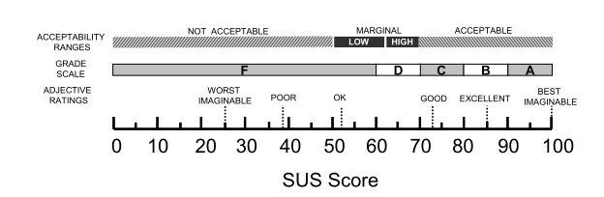
更多資訊：
1. http://www.measuringusability.com/sus.php
2. The Factor Structure of the System Usability Scale. James R. Lewis and Jeff Sauro.
3. Bangor, A.(2009)”Determining what individual SUS scores mean: Adding an adjective rating scale”.Journal of Usability Studies:114-123。
4. http://www.hansshih.com/post/85896237295/sus

