DJ2 Spec UX

Clark

Version:
V1, first run through entire flow; clarifications, general suggestions & guidelines.
V2, added clarifications, further observations, and added benchmarks.
V3, URL, Chat issues added to the top.
V4, New spec non-gui related issues added to top.
V5, Schedule update comments.
Additional suggestions
Schedule conflict dialog, calendar

10/14

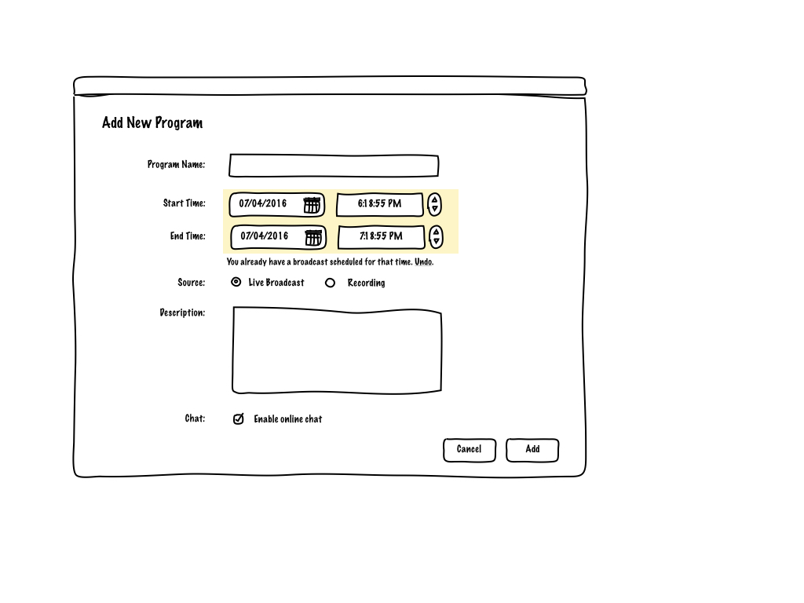
- The current method for dealing with schedule conflicts is to show a warning dialog whereby the user can not only see their error but take action to correct it. The possible weakness of this approach is that they are still far removed from their calendar view and their is potential for further error in scheduling which might cause a loop of error messages. An alternative is the above.
Generally, it’s always a good idea whenever you can to replace an error message with an Undo.
The above works by simply informing the user with an inline error message indicated with a color background and a error message with undo function.

Calendar

- Please refer to comments further down the report regarding.
It’s important to consider that it is not necessary to add a great deal of functions to this particular events calendar. With each revision the complexity of the information view increases -- originally my suggestion was in this particular software all that was required was a simple list which focused on the shows not the week. If the user wants a more complete calendar view then they should be encouraged to use a more complete solution like Google Calendar or iCal. This could be facilitated by adding data portability in the form of an RSS or iCal feed.

10/12

01 Start a channel

- If the user presses cancel, it’s best to have a message in the “blank state” guiding them to what they should do next.
- When adjusting video settings. How will we illustrate the differences for the changes to the preview window that changing the ratio will cause?
- We need to clarify what the volume adjustment is adjusting, the user needs to be informed that this is volume input levels, not output.
Broadcast setting
- Generate serial number flow still problematic

Calendar Update

- All scheduled shows are still missing important information in calendar view. I suggest you add time, a short description and possibly duration. It’s difficult for users to make an association between the time on the left and the show time itself so adding this information may help reduce their cognitive load.

- The “task list” icon has what action?

Create New

- Label in window should match label in button.

- Clicking on date field should bring up mini-calendar selector

- We cannot use a radio button to perform an action. Also only after a save or ok will the data be recorded. I suggest you change that portion of the field as follows:
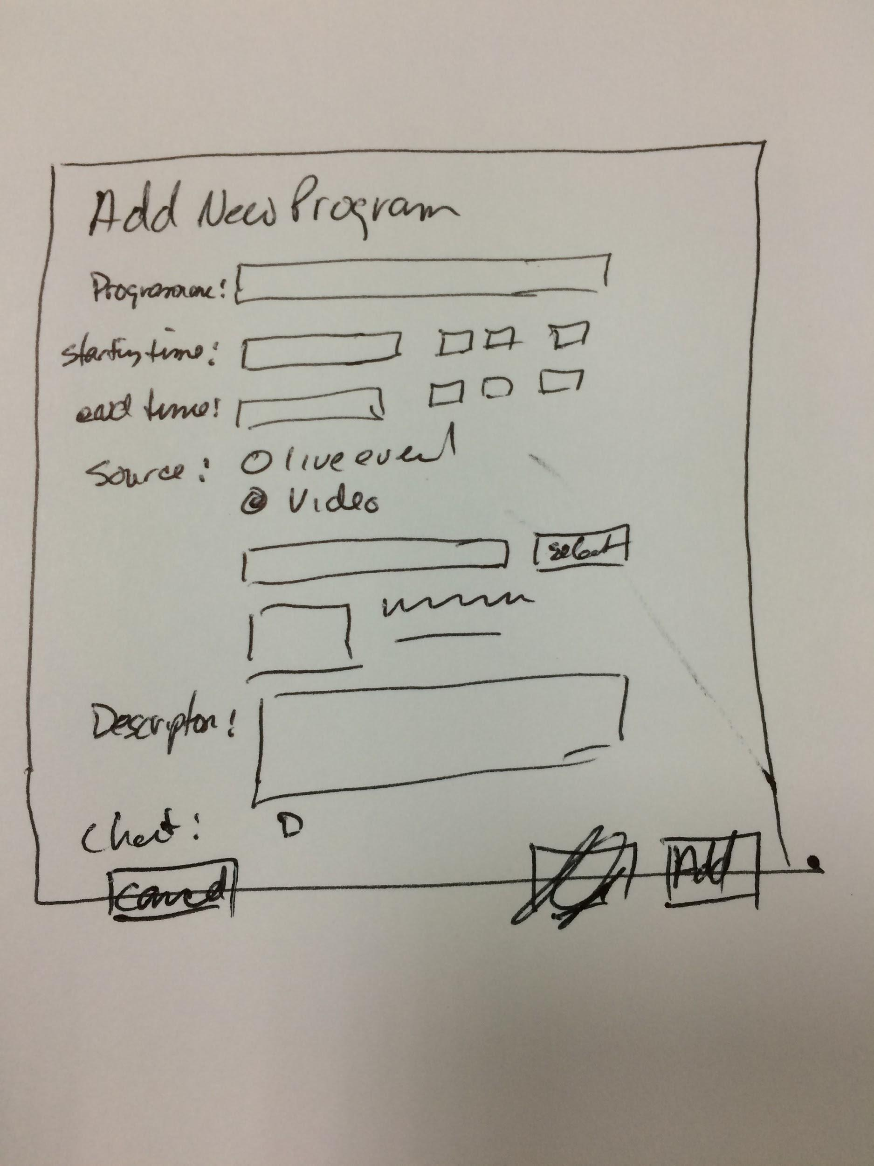

Schedule

- select a default for the user

Updated Spec.

- Create new program flow introduces too many steps, and produces a popup behaviour which may seem foreign to users. Possible solution will be to place both functions into a single drop down.
- Manage/Live - in this context using Broadcast might be a better choice. These aren’t the proper use of tabular UI as they don’t alternate between views within the same context.
- In streaming settings, the set the channel as private login with serial number uses a dropdown box, which indicates a choice, but no alternative is illustrated.
- In recordings, action drop down button: “delete” action should be removed from drop down and given it’s own button. Mixing destructive and non-destructive actions within the same drop－down menu may lead to more user error.
- Streaming video settings in broadcasting view are different from streaming video settings in the manage section.
- Streaming settings, Video and Audio: All controls are presented as a list which doesn’t provide accurate comparison/cause and effect control for the user. I suggest you separate the select input device from the adjustment, allowing users to easily compare the results of their changes. For a benchmark you can look to Skype or MacOS audio controls. See below:
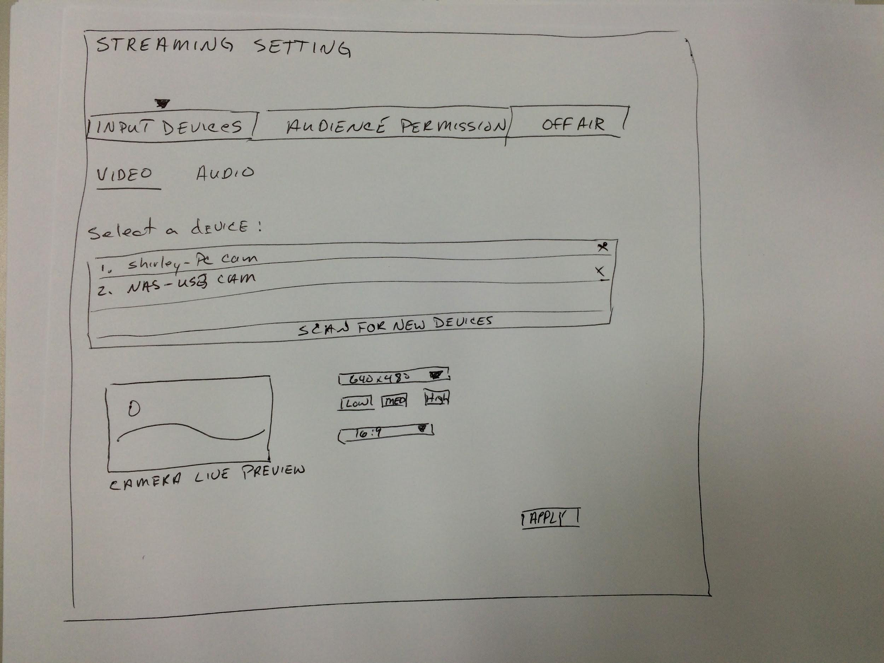

URLS
- URLs to recorded content should use a permanent URL schema. But a usable URL requires:
  - a domain name that is easy to remember and easy to spell
  - short URLs
  - easy-to-type URLs
  - URLs that visualize the information structure
  - URLs that are “ hackable “ to allow users to move to higher levels of the information architecture by hacking off the end of the URL
- The Live broadcast URL can be dynamic but they should not use MiXeD case, and be less than 78 characters long so that they will not wrap across a line feed.
  - If the live broadcast URL is dynamic, what will the user sees after the URL expires? I suggest you could 1) map the dynamic URL to the archived version if recorded or 2) create a page that states the event has past, and inviting the user to sign-up for future event announcements. You might provide a link to past videos as well.

Chat Portion issues
- Have you considered how to manage the chat experience? What if a single person is disrupting the flow of conversation?
  - Have you considered adding the ability to add controls to delete certain sentences or words?
  - Currently the chat interface is open to all to participate without logging in, correct?
  - Users should have the option to join the chat first, then see the chat stream.
  - If in this version you cannot integrate your chat with outside media or chose not to, you might consider a short registration process allowing viewers to become members. This may make it easier to control and personalise the chat experience. But currently you have no flow for this registration.
  - In order to build community it might be helpful to allow the user to see who else is viewing the stream at the same time. Vickie has created a version of the viewer interface with this concept partially included.
  - Controls to hide the chat interface and stop chat stream might be useful for users.
  - You might consider integrating integrating your chat service with Gravatar (https://en.gravatar.com) in order to allow for automatic avatars, thereby saving that step in the registration process.
  - Users might find time stamps in chat valuable, especially if the chat is ongoing.
  - A suggestion: In your introduction you stated that users would want to “create their own hub to expose themselves to the audiences they want to target thus accumulate their own influence”, another way to put this is that people want to reach an audience in order to exert influence.
Some examples: Malaysian artist Zee Avi (https://www.youtube.com/user/KokoKaina) was casually releasing songs on YouTube when she got discovered and become successful musician, Korea’s “Apple Girl” (https://www.youtube.com/user/applegirl002/ ) gained an audience on Youtube by performing songs using only a series iPhones, Hsinchu Chinese teacher Katrina Lee (https://www.youtube.com/channel/UCg5zAAP06T-PZyg1ydVmFeg ) uses Youtube to self-promote and help people learn Mandarin, people watch the live stream “Watch People Code” (http://www.watchpeoplecode.com ) as a replacement for pair programming or to learn how to code, and finally people tune into Twitch for pure entertwainment and to interact with a community.
You might better achieve this stated goal by integrating your chat interface with other popular online social media platforms; this will increase the user’s reach and resulting influence. For a benchmark you can refer to Ustream’s (https://www.ustream.tv ) implementation.

View 1 Program Playing/ No Current Show

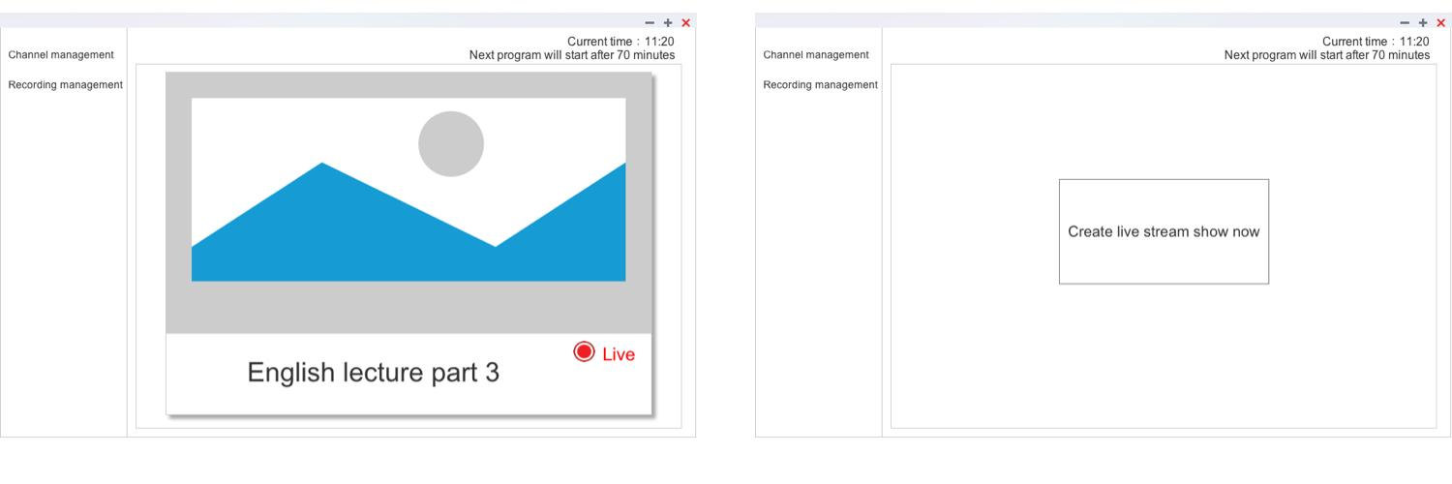

- In the current spec there isn’t an indication of a help system. Because of the various demands of this type of software your users may have some particular questions in mind, some of these questions might be addressed in your first run experience or your blank page state but others may need to be more comprehensive in nature, especially in dealing with issues unrelated to the usage of the NAS itself. If you eventually implement a help system I suggest that your users would benefit from not just describing things, but by showing people an example. You could give people examples through many different methods, including videos or detailed descriptions using photos.
- Whenever possible it’s important to support users goals throughout the experience of using DJ2. If we use two of your benchmarks as an example, your will see in the UI of uStream (http://ustream.com) that from the very first page, despite an emphasis on trying to sell their service to new customers, they have an action in the top right corner to allow users to broadcast right away. In another benchmark, Twitch (http://www.twitch.tv), from the very beginning through browse and search UI support the goal of viewing content. Most users of DJ2 will have specific goals in mind but in your current spec. the most persistent action is related to managing different views (recording and channel management) and giving users an indication of time. I suggest you adjust the UI to allow users to accomplish their specific goals no matter where they are in the UI, i.e: “Start a live broadcast”.
  - I suggest the click open streaming interface (to go live) button be present through-out the UI. This will help your users accomplish one of their main tasks in an obvious manner no matter where they are within your software.
- In the program playing window you haven’t specified any controls, can the user control from this view the currently playing video? For instance: play, pause, and volume etc..
- In the program playing window you don’t indicate from which channel this program is broadcasting, adding this information will help reduce confusion amongst your users.
- You indicate an action that when clicking on the video the user goes to the streaming interface. This action may cause some confusion for your users as the common pattern for such an action is to control the video itself and not open a new window. Also, there is currently no illustrated control to indicate such a possibility. As an example, if you go to Vimeo (https://vimeo.com) clicking on the video starts the video, clicking on the video pauses the video. This is a behavior that your users would come to expect. I suggest you consider another UI element to open that interface, preferably with a label that directly illustrates what action the user is about to do.
- Does the “Click to open streaming interface” action open in the same window or in a new window?
- The word “Live” is unclear as to what is live, in your introduction you stated that this was a recorded live show, is this correct? On a first run screen you wouldn’t be “on air” would you?
  - If this is a replayed video I suggest you make a distinction between replayed and live streaming video more obvious in your interface. To your users Live may indicate to them that the program is streaming live versus a pre-recorded video. Specificity in language helps reduce confusion for your users.
  - The red icon often refers to live show versus recorded content, you might consider different metaphors for replayed or live broadcasting.
- What is the importance of constantly displaying the time throughout your UI? Users are conditioned to looking at a specific location for time based information on their PC. Whenever possible reducing the amount of information that doesn’t directly contribute to the user‘s task reduces their cognitive load.
- The “next program will play” dialog, will this also display if the time exceeds 24hrs, a week, or a month?
- You stated in the future that the “No Current Show” view may have a listing or some kind of control for additional channels. New users are often intimidated by empty screens with little or no guidance.
You can present the user with several kinds of helpful information on a blank slate, here are a few:
- insert quick tutorials and help texts
- explain the best ways to get started
- ask questions the first-time user will ask: What is this? What do I do now?, and set expectations to help reduce frustration, intimidation, and overall confusion.
Good benchmark is Basecamp, older screenshot below:
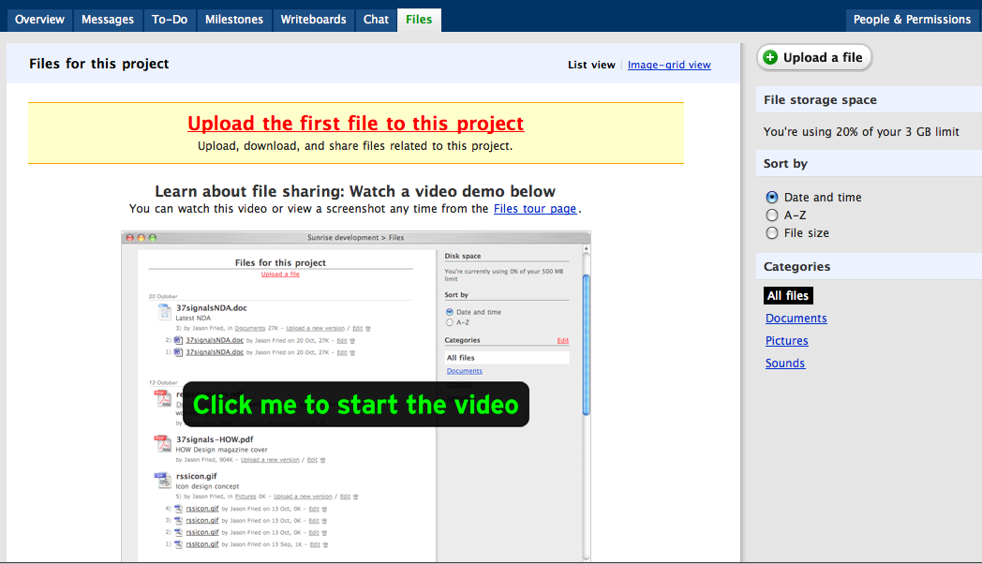
- Have you considered whether or not to allow or advise the user to perform a test of their network connection to see if it is suitable for streaming video? Some users, despite believing they have fast internet, may not realize the upload requirements for producing quality streams. As an example Wirecast (http://www.telestream.net/wirecast/) includes in their UI a bandwidth meter and online help to advise their users as to the optimal network speeds. Open Broadcast Software (https://obsproject.com) also includes a section on recommended set-up based on your test results. This information may be helpful for your users.
- There is currently in your spec. no interface or plans for a “first run experience”, is that correct? (often at QNAP this is referred to as a Quick Start Guide)
First Run Experience
  - I suggest you consider implementing a user guide. The goal should be to create a great experience for your users on their first launch of your software. You should start by talking to them, early and often. One easy way to do this is to offer the user the opportunity to take a product tour inside the product. You can use this tour to guide the user through the the basic use of the software and accomplish one task (maybe take a test video).
  - Or you spend this time setting up the environment in which the users will work, i.e.: guiding users through not just the set-up of the hardware (microphone and video), but also basic channel and program related information.
Fog Creek Software makes a product called FogBugz (they also make Trello which we have been experimenting with), which does bug tracking and project management. The FogBugz tour focuses on how the user, likely a software developer, can collaborate with their team better over FogBugz than say using email. When they first start the free trial, they’re given a one-click option to either take or dismiss the tour, and they can quit it at any time. The user always remains in control. The tour walks through the basic operation of the software while explaining how that will make their development process better. It then concludes with an explicit invitation for them to invite their team members into FogBugz.
You can view more benchmarks at https://www.useronboard.com/

Channel Management

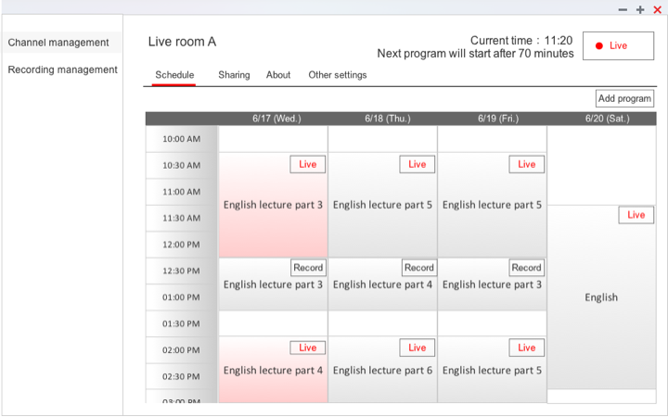

- Reminder: each function, section, or UI element has to accurately describe what it does. There are some elements through-out that UI that are described in a way that might cause confusion amongst your users. At best your language should reinforce the metaphor or concept you are using through-out your software. If you visit ustream (https://www.ustream.tv) you will notice that there UI language is heavily influenced by life event television (sporting/live events etc.).
  - You can look at this glossary of broadcast terms (https://en.wikipedia.org/wiki/Glossary_of_broadcasting_terms) for inspiration. The language you use in your concept and UI frames how the user thinks of your product. We need to be sure to use terms that match the user’s mental model of the service and actions that they are going to perform. Even though you may say you “want to appeal to everyone” you still need to carefully select what copy you use to select use in your UI and descriptions.
- In each tab in Channel Management there is a lack of content guiding the user as to what they can accomplish in each section. I suggest you use short blocks of info or text to introduce each section. People prefer short line lengths, but they read better with longer ones! It’s a conundrum, so decide whether preference or performance is more important in your case.
- Do you intend to implement a full featured calendar in your spec., and if so in what form will it appear? You might consider a different approach than the common boxed calendars that are made for day-to-day planning, they are not designed to provide an overview of upcoming events, the main purpose of the event calendar. I suggest you start with a text list of events. The text list is great for providing a view of events for a given period of time: for a certain day, week, month, or simply the nearest future. CBC Program Guide (http://www.cbc.ca/programguide/daily/today/documentary) and Radio Australia (http://www.radioaustralia.net.au/international/radio/programschedule) are good general examples. Ustream (http://www.ustream.tv/) provides perhaps the best benchmark. There are a number of additional ways to display event based information which I can discuss with you if you wish.
- In your calendar display you list some example content but it is missing information which would be important to the user. Users will find the following basic information with each listing most valuable: title of the event, date of the event, start time, and description of the event.
- I suggest you add some additional information under the Channel name to both make it more clear to the user (the broadcaster) as to it’s purpose and when the last show was broadcast. This may at present seem less essential but in the future when you add more channel capability it might help the user distinguish between similar channels and reduce their cognitive load.
- The “Live” button is unclear as to what is actually “live” (please refer to previous detail).
- Currently there is only one room, how many do you envision in the future there might be?
- I want to confirm your channel/room concept. Live Room A is a channel within DJ2, and within Live Room A there could be many shows, some “Live”, while some are “Replays” of previous live shows and some which may have been previously recorded, is this correct?
- In between each live show or replayed live show there could be what you refer to as a bridge. What will the audience of the channel see if the user selects audio as their bridge content? What will the audience see if no bridge is scheduled?
- There are 2 possible actions when clicking on the calendar, one when you click on an event itself and another when you want to add either a new event or a new bridge. Do you intend this behavior to mirror a desktop experience (ie. If you click on Apple’s iCal a dialog appears and you add or edit an event)? Or is it possible to add a more explicit action button or some other UI element to make this action more obvious?
  - In particular users may find a single click to reveal a further 2 options (add program or add bridge) particularly complex. One possible suggestion is to reduce the click result to a single window whereby the user has a choice between editing/adding a program, and adding a bridge.
  - Suggestion: When requiring users to enter time based data natural language input is best.
Examples: Fantastical – natural language input calendar, Motaword – natural language input, Natural Language Form – natural language input.
- What happens if you schedule a live streamed program into the schedule and the live stream lasts longer than you had planned and conflicts with a scheduled pre-recorded show? I suggest you add the capability to warn the user of a scheduling conflict.
- Add and Edit screen are for live streamed shows only, is this correct? When adding a scheduled live stream would you not also want to add the start time or adjust the start time? I realise that you can do so in the calendar that you have displayed at present but often users may want to make adjustments when in that dialog.
- Since you are presenting users a complete view of their broadcast schedule users might also find this an ideal location to add pre-recorded content. The “Add to Channel Schedule” interface in recording management isn’t as robust and users are currently required to go back and forth between each page to accurately place a show.
- In edit or add new program, you can select a range of social networks to announce your broadcast to. Have these have already been set-up in the sharing tab? If the user selects all the social networks to post to but only one or two have been pre-connected what will the result be? Will all the “oauth” or other authentication method windows open on click?
- In edit or add new program, Users who have a large following or who are trying to gain a wider audience might appreciate being able to adjust the message that is being sent out for that particular broadcast. For example, perhaps there is a particularly trending hash tag on twitter you want to add to your announcement. But by adding that to the description field it will also show up in the program listing.
- In edit or add new program, Users might not be aware of each platform’s particular restrictions as to description length, i.e: Twitter places a limit of 140 characters for each post. Adding the ability to customize the announcement to each social media platform might alleviate any frustration the users have with how their announcement appears when published.
  - Also each platform has particular unique features, Facebook allows you to embed a photo or video in your post, how will the appearance of the announcement differ on Facebook compared to Twitter or other platforms? For example, Hootsuite (http://hootsuite.com) allows you to customize your message in their UI when you are posting to different services.
- In edit or add new program, create new bridge, schedule you have the option to schedule a new bridge before and after a specific program at specific intervals. Unfortunately, with the potential of a long list of programs (shows) using this type of interface may lead to frustration for your users. Drop down interface elements are very inefficient when you need to select from a long list of items.
  - In this dialog, giving the users the option to schedule a bridge in the distant future may result in scheduling conflicts as they have no ability in the interface to see future events. What will happen if there is a scheduling conflict between a bridge and a program? I suggest you either set defaults for what will play during non-broadcast times and/or provide an error message if a conflict appears.
- In edit or add new program, advanced settings, are the settings here populated with defaults or must you continuously adjust settings each time you create a new live show? It’s important to provide intelligent defaults. Defaults let people do less work to get the job done.
Sharing Tab
- In the pushing to social network you are using a drop down which allows for only one selection at a time. Your users might wish set a default to push to multiple networks at the same time but the current UI setting will not allow them to do so.
  - For social sharing at specific times I suggest you can refer to Hootsuite (http://hootsuite.com) and Bufferapp (https://buffer.com) as benchmarks.
- Here, and at least in one other location, you provide the user with the ability to select a date range to perform an action. In this case it is to mail a program schedule to a list of recipients at a specific time. Currently you haven’t specified what that date range will be. I suggest you offer several preset date ranges that users will want to use frequently. However, users who want to specify a custom date range can click a more link, which expands a group of standard date pickers, comprising text boxes and calendars. In many cases, using this design pattern instead of a simple date range picker can save time and reduce cognitive loading for users, while still allowing complete flexibility with only a single extra click. Below is an example:
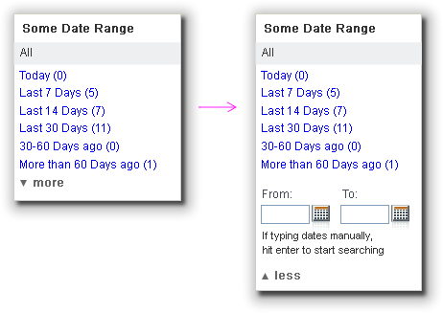
- Currently in the email list you need to delete each contact manually, this may cause your Users frustration if they need to delete a number of contacts. I suggest you add a range selector to allow for mass deletion or possibly in the future some collective editing function.
- What will the email schedule look like? What if the recipient of the email wants to be removed from the list, how will they do so?
- Does the sending of email require any special set-up within QTS itself? If so, the user should be notified before they enter in any data that they must first set-up that function within QTS before any email will be sent.
- When there isn’t any data in the email list what will the blank state look like? I suggest a simple message informing the user they can use this function or if required inviting them to set-up the email send function itself.
- The user must add each email contact manually is that correct? You might consider in the future adding an import function in the future. Even the ability to import a .csv file would greatly speed up their workflow.
- If a Viewer in the Client Flow chooses to follow the channel will they automatically be added to this list?
- The sharing tab is a better location to add the social network connection function as it groups like functions together and will reduce the incidence of user errors.
  - Setting up your social network connections is required first before you can announce your program on various social networks. In order to reduce user error, I suggest you provide a reminder to your users that they first need to set-up their social network connections before they can push their program. Or/and you don’t allow the icons to appear until the social network has been set-up. This is the approach that Wordpress (http://wordpress.com) takes with their social media sharing interface. You can’t share to a service you previously haven’t authorized.
- There is a potential for a catastrophic user error on this page if after entering a great deal of data the user accidently leaves the page without saving their data. I suggest you create a dialog that asks the user to confirm they want to leave the page before saving data (this type of dialog appears in many locations through-out QTS). A greater improvement would be to offer automatic saving after entering each email contact (and a confirmation dialog to confirm that it indeed has been saved).
- In the sharing section you are sharing two different things over a range of different times. I want to specifically point out that it needs to be made very clear the distinction between the two. One is for announcing program schedules while the other is for announcing shows. The language and the UI should reflect this difference, later as you strengthen the capabilities of each of these sections you might consider separating these two to their own sections.
About Tab
- For the description text block are there any restrictions as to the length of text that can be entered. Where will this text be used? I subtle reminder to the user as to where it will be seen will help them tailor the description for it’s intended purpose.
- The channel picture will only be used in the client flow part of your spec correct? What will be displayed if they decide not to use a custom picture? You might provide an attractive default, thereby allowing you to address the problem stated below.
- If you have a great default picture a different approach might be to give the button the label “edit default picture”.
  - When clicking on this button what happens? Does it open a computer dialog that allows you to use your PC’s file system, or is the source of the picture on the NAS?
  - What function does the text field offer?
- Buttons should be very explicit in their intended function. The browse button leads me to ask, browse for what, or browse where? Some users do read those labels, so we need to help them by writing button labels that clearly explain what each button does. When labeling buttons, try to explain what the button does. Are choosing files and uploading two steps or a single step? In the case of dropbox, you choose the files and then press ‘upload’. ‘Choose files’ is clear enough to tell you the action it performs and concise enough to fit within two words. ‘Select files’ also works.
- As I stated earlier I believe the the Social network connecting section is better grouped within the sharing section. It provides a better match to your user’s mental model of where these functions co-exist.
- A reminder, when you connect your software or service to a social network, you must go through their authentication process. And each service has its’ own UI and process for doing so. It’s not possible to simply log-in via your edit log-in information dialog, nor can you directly connect to other networks via the flow you have detailed.
- Since you cannot directly manipulate your log-in credentials within DJ2 itself, the edit icon set along side each social may need to be changed to represent some other action.
Other settings tab
- Does this set the defaults that can be used for streaming, privacy, chat, and recording throughout DJ2?
- When setting maximum “watchers” it would be helpful for your users to include any possible real limits as to how many people can actually view the stream. These limits might be set by the hardware itself, network capability, or network conditions. (IE: 5/10)
- Are there any conditions whereby a user might want to set a delay (to live) longer than the range you have suggested? If there is a benefit to a longer delay than perhaps that should be explained to the user via a short explanation.
- Setting the channel as private, is this the same privacy concept that appears through-out other stations in QTS? In other similar services to DJ2 the concept of setting a video to private differs slightly from the access controls provided in a NAS.
  - How does setting the recorded video as public differ from setting the channel as private? If I check this will all the videos I record be available for viewing regardless of whether or not they are in a channel that is private?
- There appears to be some redundancy that may confuse some users with your Video and Audio input management function.
  - A user can with both the audio and video drop down UI elements select an input device, correct?
  - It appears that the IP information is automatically populated into the settings? Are these devices automatically discovered? Can I use an input device outside my local area network?
  - What happens if a device is not found?
  - Are there any particular hardware requirements that the user should be made aware of? For example, will any USB cam work?
  - What happens if the user mistakenly disconnects the video or audio device? Will any message appear to warn the user that their input device has been removed?
  - In the input device settings a user can input a name of their choosing to describe the device, is this correct?
  - Since it appears that the input devices are discovered and the IP is populated, is there any benefit to all the extra dialog boxes and steps that you illustrate in the various input management views? If there is any possible way that we can reduce the number of steps a user needs to take in order complete a task, it’s worth considering if we can do much of these tasks in one view.
- Within record settings there is an option to record while streaming, when this is set the only way you can change this decision is by returning to this view and deselecting that option correct? Allowing users to override this decision on a stream by stream basis might reduce their cognitive load. Memory is fragile. It degrades quickly and is subject to lots of errors. Don’t make people remember things from one task to another or one page to another.
- A reminder about button labels: Video saving path button label is unclear.

Recording Management

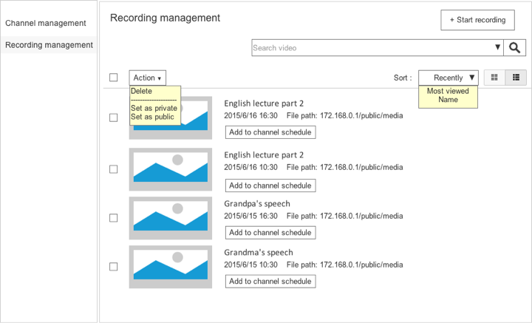

- In your spec their needs to be a clearer distinction between a Live Stream, a recording, and a live stream that was recorded. For the viewer there is a completely different experience when viewing a broadcast that was recorded live and a video that was carefully pre-recorded, this difference needs to also be reflected in your UI.
- Currently there is no interface to allow the user to stream a recorded video from a source other than DJ2 or upload , i.e. you might have older English classroom videos on your NAS you would like to share, or videos professionally produced that you would like to stream. In future versions you might consider adding this function as it may be valuable to your users.
- The recording list view is missing some information which might be valuable to your users. They require: title, date and time, length, and description of the recording.
- Is the file path something that users of this software would need to see? Many users still appreciate file hierarchies and being able to control where they place their files (unlike iOS’s approach) but I feel at this place this type of information may prove too “technical” for your users (it seems like an idea remnant from other NAS software) and this space might be best left for other more important information.
- The picture shown in the list and icon view will be what? Will it be possible for the user to set a photo to represent the video in the future? Or set a still frame? Or will the UI just have as presented now a default image representing a video?
- How will the user manage a large number of recordings? Currently the UI is sufficient to manage a small set, but in the future if the user decides to add 100’s or more a more robust system will be needed. I suggest you considering adding the ability for the user to add tags for each video and adding the ability to filter not just by most viewed and name, but by tags as well.
- What will the search results look like? Currently you don’t have a search results page. Here are a few ideas based on usability best practices which might help you get started:
- The search results page shows the user what was searched for and it is easy to edit and resubmit the search.
- Search results are clear, useful and ranked by relevance.
- If no results are returned, the system offers ideas or options for improving the query based on identifiable problems with the user’s input.
- The search engine handles empty queries gracefully.
- The search interface includes examples or hints on how to use it effectively.
- Complex searches can be saved and executed on a regular basis (so users can keep up-to-date with dynamic content).
- The search results page displays useful meta-data, such as the title, date and time, length, and description of the recording.
- The search engine provides automatic spell checking and looks for plurals and synonyms.

- The drop down arrow in the search box has what function, it’s not yet indicated what it’s function is.
- When you add recording to the channel schedule the user currently has no idea what has been scheduled and because the user’s memory is very fragile they will not remember. I suggest:
  - you first create an interface for a scheduling conflict if the time the user selects is conflicts with another program.
  - You provide an interface from this view which provides access to the schedule, so that users can accurately add a program to their schedule.
  - Later as you add more channels a UI will need to be added to allow users to select channel first then schedule the recording.
  - Since the recording has definitive time based meta-data, the interface could suggest which time frame would be best to schedule the recorded video, thus reducing the users cognitive load by providing intelligent assistance.
- Reminder: When adding a new recording to the schedule, the recording will have a definite length of time, adding the estimated end time data is an incorrect value request.
- Delete video action needs a confirmation dialog to ensure that users do not delete data in error. This action is likely one of the most critical in all of DJ2, as the potential for accidental loss of data is great. Further suggestions:
  - The “Acknowledge and Provide an Option to Undo” from Android Patterns is a good strategy for deletes.
  - Instead of providing a simple confirm delete button in a dialog box, you require users to actually type delete into a text field in that dialog box. Clicking through dialog boxes for users is almost a reflex, but entering data into a form requires the user to stop and think about the action they want to perform. It’s not “user friendly” but it protects the user from catastrophic errors.
- In the create new recording dialog there is no option for the user to enter a description. This might be the best place to enter a description which could be used as a default value for the add new program dialog. In the add new program dialog the user could then tailor that description to suit that particular broadcast.
- What does setting the recording to public do? Does this follow QTS conventions or does it allow the audience view?
- Reminder: The saving video path button is not concise. Buttons need to be explicit in their intended actions.
- The video saving path text box serves what purpose? If it is for entering the file saving path manually, how many of your users would actually remember this information?
- Create new program, Create new recording, and Input management are all pop ups correct? The Input management pop up will then appear above the Create new recording if selected correct?

Create Live Stream Show Now

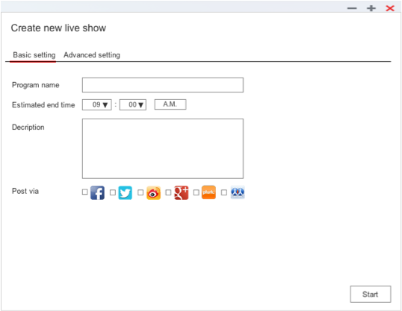

- Reminder: Basic and Advanced setting’s labels represent completely different things. Basic is information related to the program itself, the other related to the technology that delivers it. Generally, when you use basic and advanced labels there is a closer relationship between the two. Advanced might in many instances mean more detail, and in fact it has for many users a negative connotation. Average users avoid advanced settings (which is why you don’t see “advanced search” as often as you used to).
- What purpose does the estimated end time function have? You are asking users to enter exact data based on an estimated assumption, the logic of this might cause your users some problems.
- Post via line. If the users haven’t yet connected with the social media services and they select one to post, what will be the result? I suggest you only reveal icons or services they can post to when those services have been connected to. That way you can reduce confusion amongst your users. This is the method used by social media management software like Bufferapp (https://buffer.com) and publishing platforms like Wordpress.
- What happens if I create a live show now, there is already a program scheduled, or about to be broadcast but the user is not aware? I suggest in that case you might want to inform the user via a message on screen of any conflicts that might arise.
- I’ve mentioned the input management UI earlier.
- In the input management UI window the user has the option to change the streaming resolution, what effect will that have on the broadcast quality? If it has a large effect than we need to inform the user of the advantages or disadvantages of that decision.

Streaming Interface

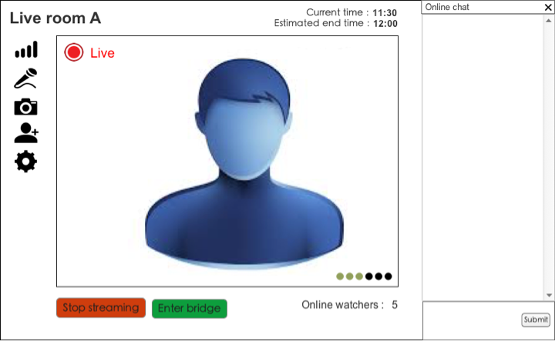

- When the user enters this view do they after the initial buffering period start streaming their program? If this is the flow you envision, then it might produce some problems for your users. I suggest you first allow the software to prepare the stream and than allow the user to have definite control of the start and stop experience via a button below the window.
- If the user enters the streaming interface when there is an already schedule bridge what will happen? I suggest we display a notice to notify the user that a bridge is already broadcasting.
- The bandwidth UI uses a slider interface which are best used for non definitive value adjustments. I suggest you change the UI to allow for specific control, perhaps via button UI that allows the user to select a specific value.
- The microphone button attaches two actions to one state. When you click the microphone button you silence the audio, this would match the users mental model of such an action. But additionally you also launch a popup whereby they can also select a bridge. This may confuse users and it adds complication to a fairly common and simple interaction. I suggest you separate this function from this UI element.
- Also, in the add audio bridge popup window you have a radio button that allows users to select the default. But if it’s the default it would have been already selected. What the user would want to do is to change the default or edit the default.
- The add video bridge has some flow problems which may cause confusion amongst your users. Like above, users don’t actually select a default, the default has already been selected. But you first ask the user to select a content type. Does that mean that there is a default for each content type?
  - What would a text video bridge look like?
  - Like the problems stated in the audio icon you are attaching two actions too one state. Again you may want to separate these functions or simply allow the user to at this point be content with a default.
- In invite dialog you have a field that contains an embed code or an invite link? Embed codes are entirely different than simple links. I suggest you might want to separate these into separate fields.
- In the invite by email section, how can the user invite more than one person? How could the user from this interface invite five or more people at one time? If the email address was already in the system would the system notify the user, or is this function completely unrelated to the mail list?
- Reminder: Invite Dialog. Save button, we aren’t actually saving data are we?
- Is the “x” in the upper right hand corner a close chat button? If so, the location might confuse users to believing they are closing the window. A more ideal solution would be to have a more recognizable icon placed where there wouldn’t be as great a chance of error.
- I have some specific suggestions with regards to the placement of the UI controls and titles and text at the end of the Client Flow section.

Client Flow

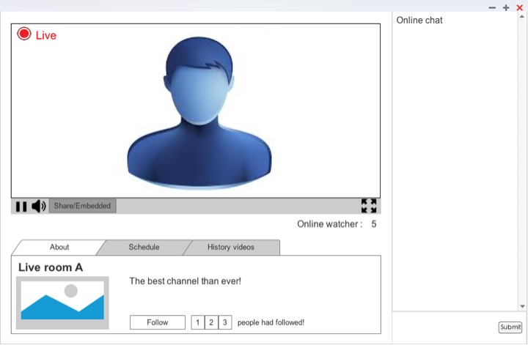

- I suggest that you include a control that allows users (viewers) to change the video resolution on demand. Unlike in Taiwan, in many part of the world you don’t have a internet flat rate, but either pay per MB or get a Quota of x GB/month. Network conditions vary and user should be allowed to make manual adjustments.
- Are there any requirements that the viewers need to have in order to view the stream? Do they need flash or is it an HTML 5 based player? Do they get any notifications if there are problems?
- I suggest you deliver interactivity as an opt-in experience, not an opt-out. Depending on your target user, the automatic addition of chat may be a distraction. People can only look at so much information or read so much text on a screen without losing interest. Only provide the information that’s needed at the moment.
- In the About tab you have a short description to the right of the channel picture, what happens if the description that the user has entered is too long for the space provided?
- Is the client view for live shows the same as recorded?
- Will the chatroom messages persist? Or will they be erased after each session?

- Will the client be hosted on a webpage? If it is hosted on a webpage, then how will the schedule and archive of past videos appear?
- Reminder: In the client view we will need to deliver to the user information about the program, channel, and broadcaster.

- Since the client view is a web page, will the user have to set-up any functions within the NAS to allow it to act as a web server? If so, what will that interface look like?
- In the spec there is an interface for archives of past videos and schedule of upcoming (and possibly past) shows but the content in the spec is limited. How full featured will this be? Will the user be able to browse through past archives of videos? What if this archive is in the hundreds? Users have certain expectations when viewing schedules and media archives online which in the current spec is not clear.
- Will it be possible for the viewer to download pre-recorded videos?
- Upon arriving to view the live broadcast the user might want to view other videos from that channel? In addition to an archive, I suggest you create channel pages to give viewers an idea of past programs, via a listing of previously broadcast videos.
- Will there be space for information about the broadcaster? A short bio and links to various social media platforms might suffice.

- Video Player UI Suggestions (also related to streaming/recording)
  - Player controls are best placed on the bottom
Please ensure most important controls are placed at the bottom. Bottom positioning is usually used with players that have both audio and video possibilities. It pretty much an established pattern but has some real usability advantages as well. In video playback and recording most important stage activities are usually placed over the middle of the frame (especially faces/eyes of video participants). This allows the user manipulate feedback without moving the cursor over the scene, disturbing or interfering with any action that might be taking place.
  - Controls: If you have any concern about accessibility, your audience may include those with physical constraints, or users of a certain age, than how you implement the progress bar can also change. Make dragging left/right on the video move the progress bar too - not just dragging on the progress bar. This action may also be more convenient.
  - Where to put the title of video?
It depends whether the video is the subject of the article / content, or whether it’s just an accompaniment.
If the page or content is ‘about’ the video, adding the title to the top of the page helps give it a parental relationship to the whole page.
On the other hand, if the video is just illustrates a larger article, the title needs to be attached to the video and nothing else.
  - Use spacebar for pausing video
Pausing playback is one of the most common interactions a user does when viewing a video. Therefore mapping the most accessible keyboard button, space, to access that feature seems quite straight forward. There is no larger button on the keyboard. This has become a fairly established pattern.
- Video Autoplay Suggestions
  - Autoplay is an interruption and a bad idea for usability while browsing. The sound from the clip will override or conflict with other sounds that any user is listening to at that time.
  - “ .. we discourage the practice of automatically starting sounds (especially if they last more than 3 seconds), and encourage that the sound be started by an action initiated by the user after they reach the page, rather than requiring that the sound be stopped by an action of the user after they land on the page.” ‘Understanding Success Criterion 1.4.2 [Audio Control]’
  - Only automatically play video if the clip lasts for five seconds or fewer. If the clip lasts for more than five seconds, you must provide the user with the option to stop or pause it.
  - Automatic playback is generally acceptable if the user was aware, when they clicked the link, that the proceeding page was going to play a clip.
  - If you auto-play and can’t guarantee the users environment you should sent to mute like FB.
- Player audio starting levels. Your default volume should be mute, unless the users task is focused on viewing that video at that time. Otherwise, you should set the starting volume to 80%. That way the user can easily adjust the volume up or down to compensate for inconsistencies in the sound level. Not thinking about volume could cause problems for users by affecting the sound quality or being too intrusive for there particular environment, you don’t know what the user was listening to previously.

Benchmarking
Screen shots and specific patterns are contained within a separate document or folders.

Mobile
Periscope - Explore the world through someone else's eyes
Meerkat - Live Stream Video. (@kelake)
myTape - Social Video Camera
Yahoo Livetext - Video Messenger, Concept, immediacy, UI
Stre.am - Live video from your phone
Streambox
Kaboom

Concept
HangW/ - The most advanced live-streaming mobile & social experience on the planet!
Platzi - Live streaming classes on design, marketing, and code
Watch People Code - Livestreams of people coding
Skillshare
Live coding - Watch people code
Watch Me Work
Twitch.tv
http://www.ustream.tv/ - UI, Concept, Language
Ticker.tv - Livestreaming network of traders and investors
Chew.tv - Watch the best DJs perform live, anywhere in the world.
Upclose - Livestream and get real time feedback
Making Live - Watch how people make cool things in real time.
ChineseTeachers.com
http://live.fc2.com/tw/
http://www.yy.com/49467123/
http://www.xiu8.com/
https://livehouse.in/
http://www.6.cn/
http://pikolive.com/
https://www.picarto.tv
http://loadingreadyrun.com/live
https://streamup.com
https://streamium.io
https://sywork.tv

Testing/Coventions
OBS – Testing and help, some patterns
Wirecast – stream testing, patterns

Social Sharing
Wordpress.com –Jetpack plugin social media sharing
http://hootsuite.com - social media sharing, patterns
Bufferapp – social media sharing
Buffer Pablo – designing social media shares
MailChimp – email marketing
http://www.ustream.tv/

Player
Vimeo – player UI
JWPlayer – volume set to 80% as default
Youtube
http://www.ustream.tv/

First Run Experience
User Onboarding – first run experience benchmarking
FogBugz
Basecamp

Calendar
http://www.bbc.co.uk/radio4/programmes/schedules
http://www.cbc.ca/programguide/daily/today/documentary
http://www.ustream.tv/
Fantastical – natural language input
Motaword – natural language input
Natural Language Form – natural language input
Google IO
Comedy Central

Blank State
Basecamp
Wufoo

